**Name**: Karthikeyan K R

**Date**: 10-01-2024

**Topic**: Creation and Execution of YAML Pipelines

**Type**: Daily Assignment

**YAML Pipeline**:

* YAML stands for Yet Another markup Language
* YAML pipeline refers to a configuration file written in YAML, that defines a continuous integration and continuous delivery (CI/CD) pipeline
* YAML is a human-readable data serialization format, and in the context of CI/CD, a YAML pipeline is a way to express the stages and tasks involved in automating the building, testing, and deployment of software applications.

**Step-1**: Login to your azure account and go to the DevOps organization

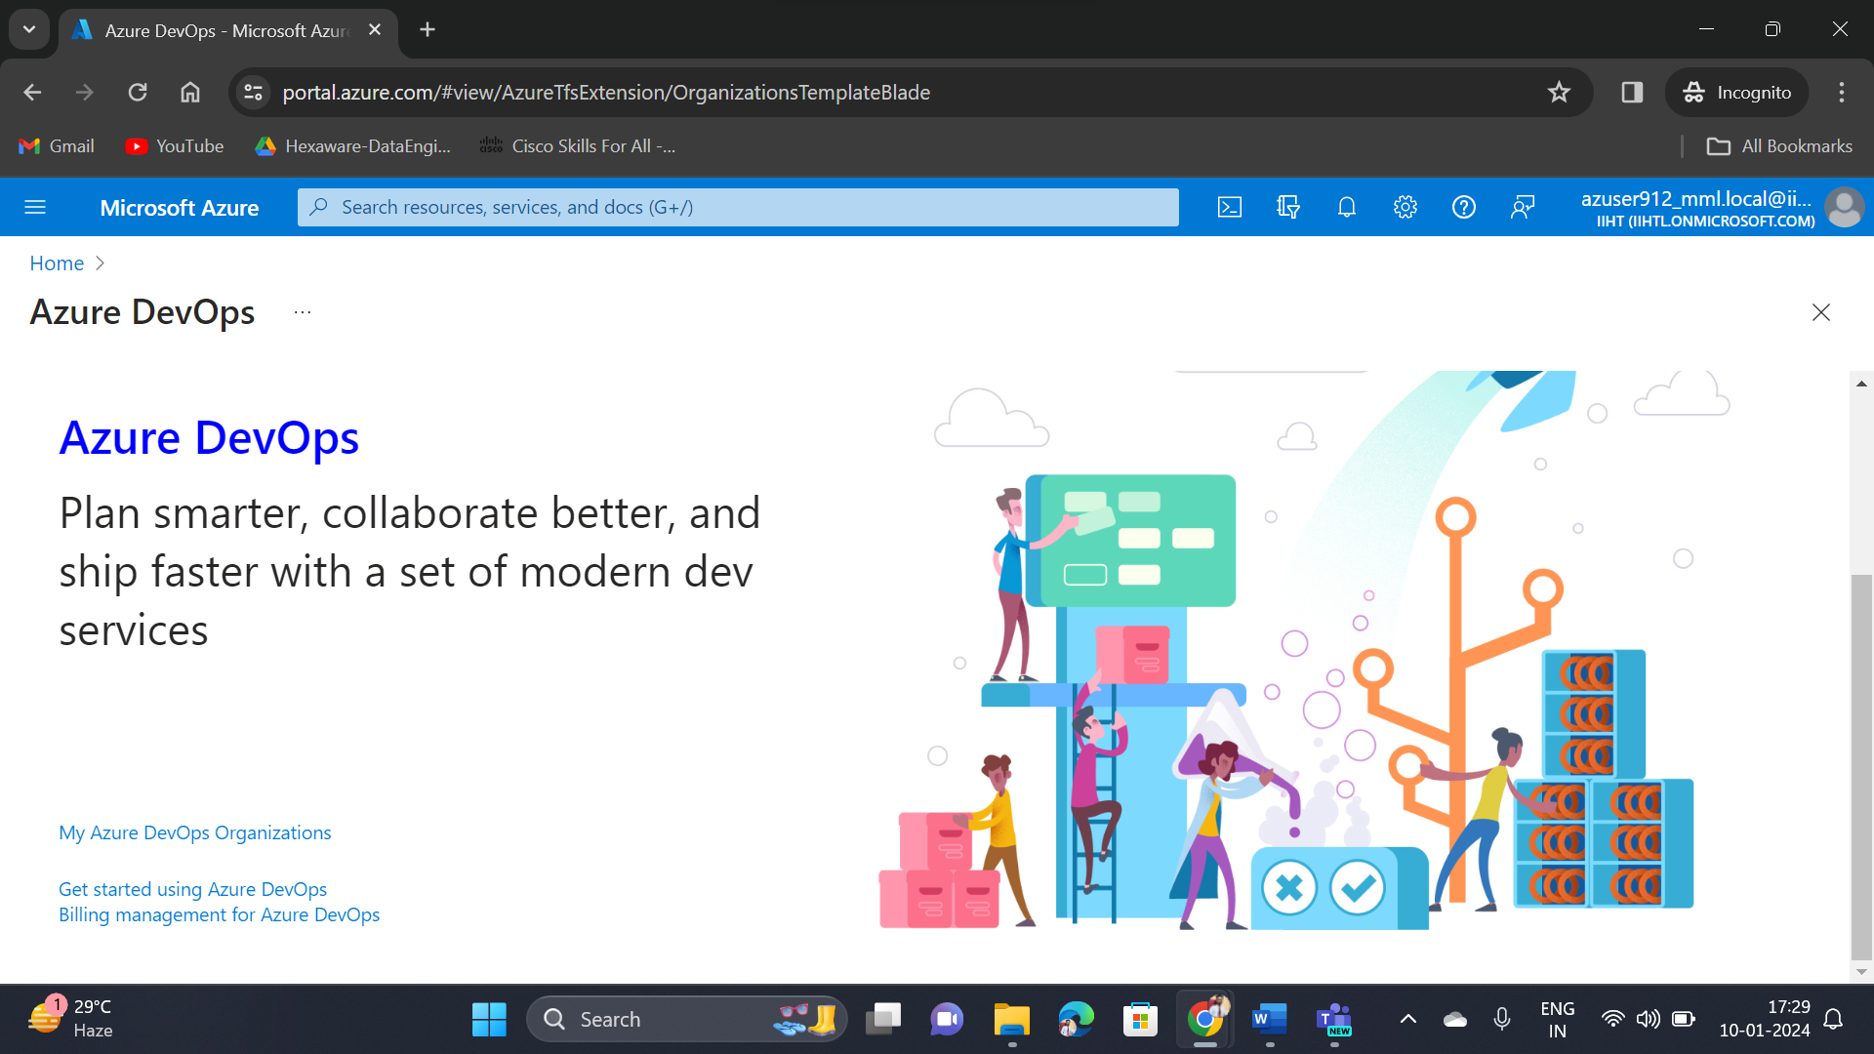

**Step-2**: Go to your Organization and select the project

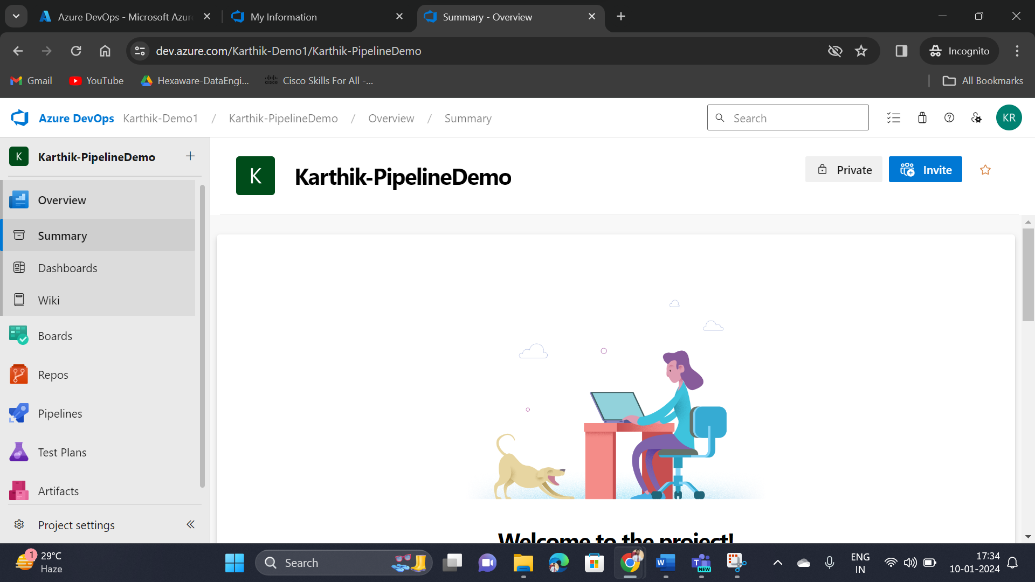

**Step-3**: Then select the pipelines service and create your pipeline

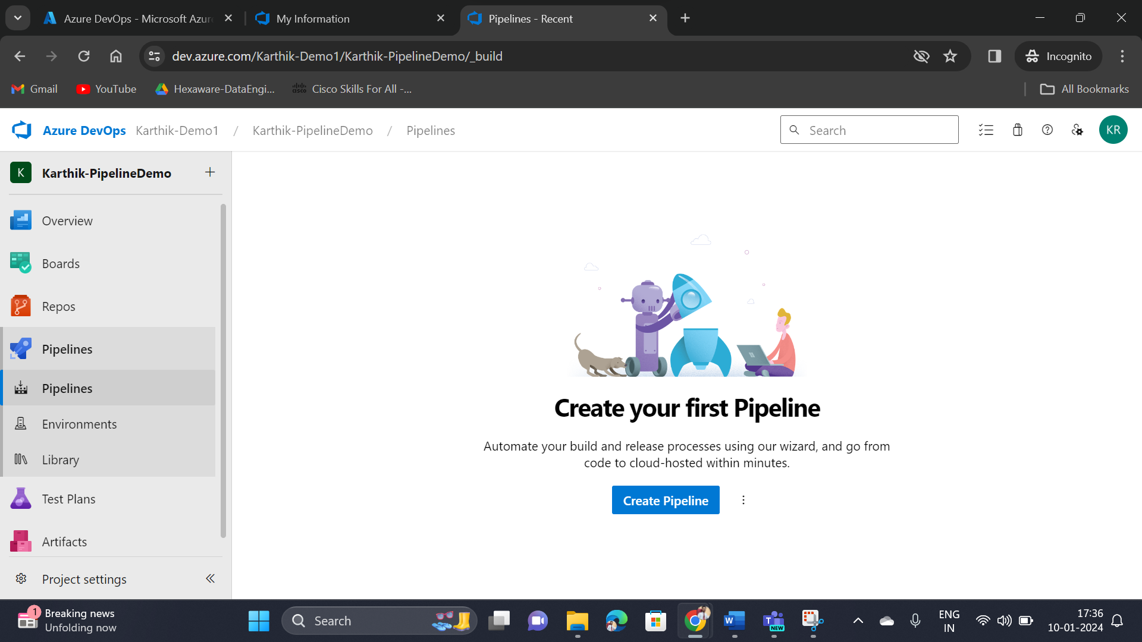

**Step-4**: Select connection where the pipelines need to be connected, I have selected Azure Repos Git

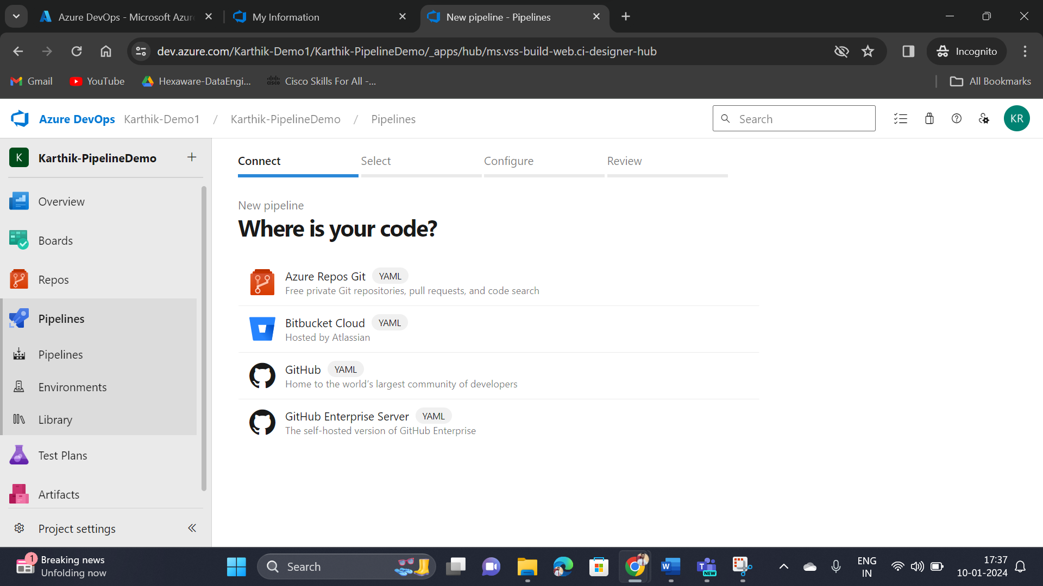

**Step-5**: Now select the repository

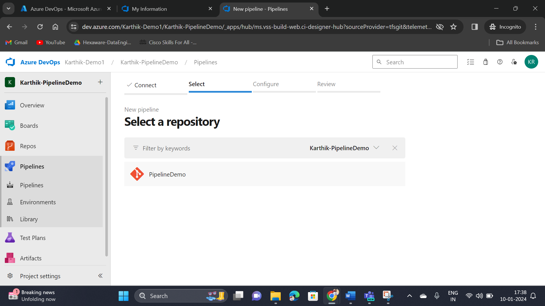

**Step-6**: For Configuration, choose the starter pipeline

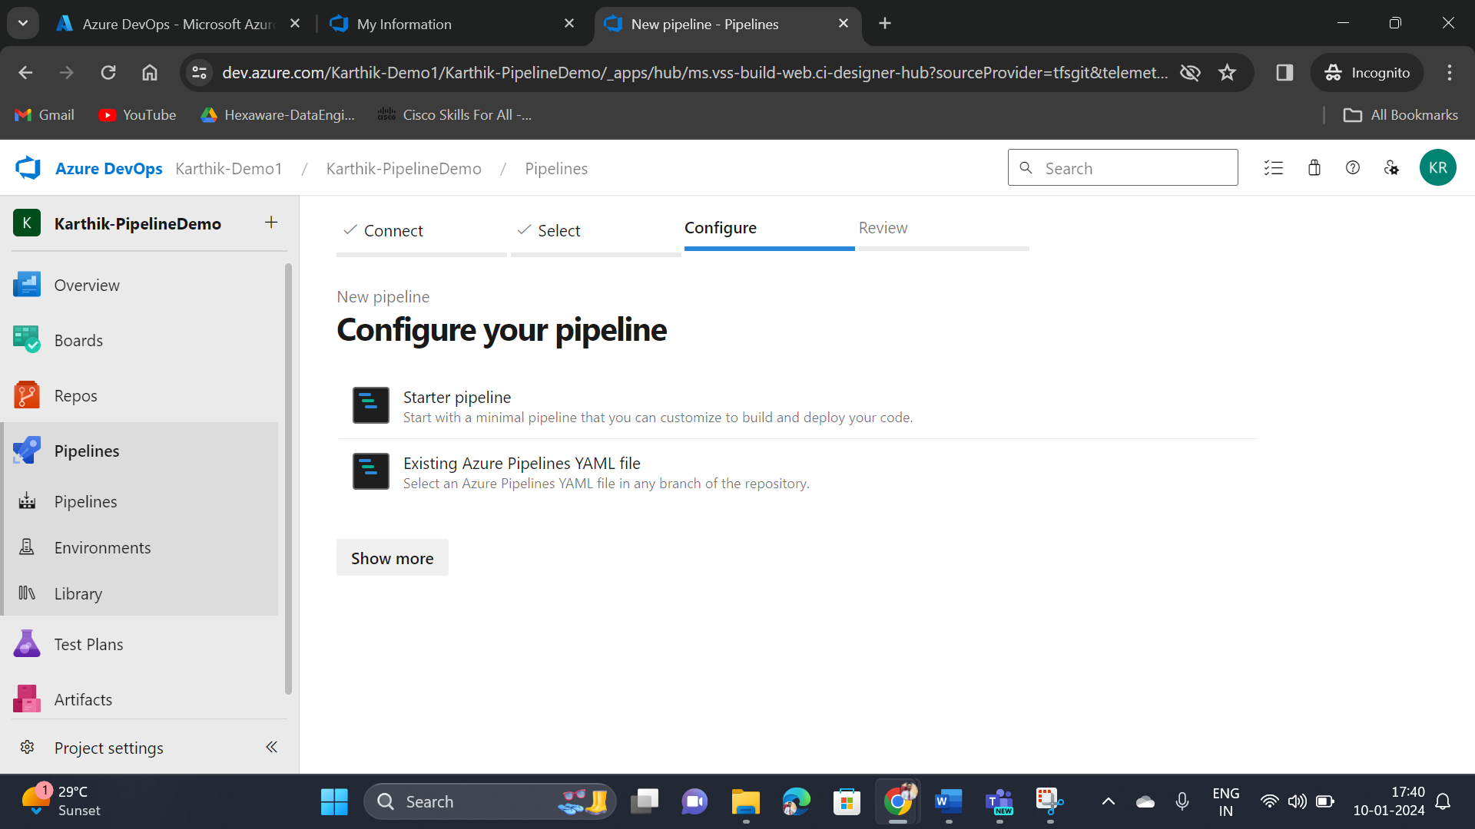

**Step-7**: Now review your YAML pipeline sand click save and run

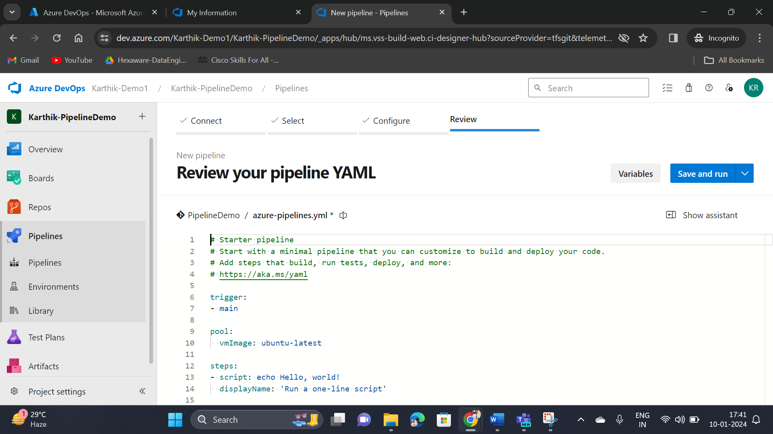

**Step-8**: Now give the commit message and choose option, commit directly to the main branch

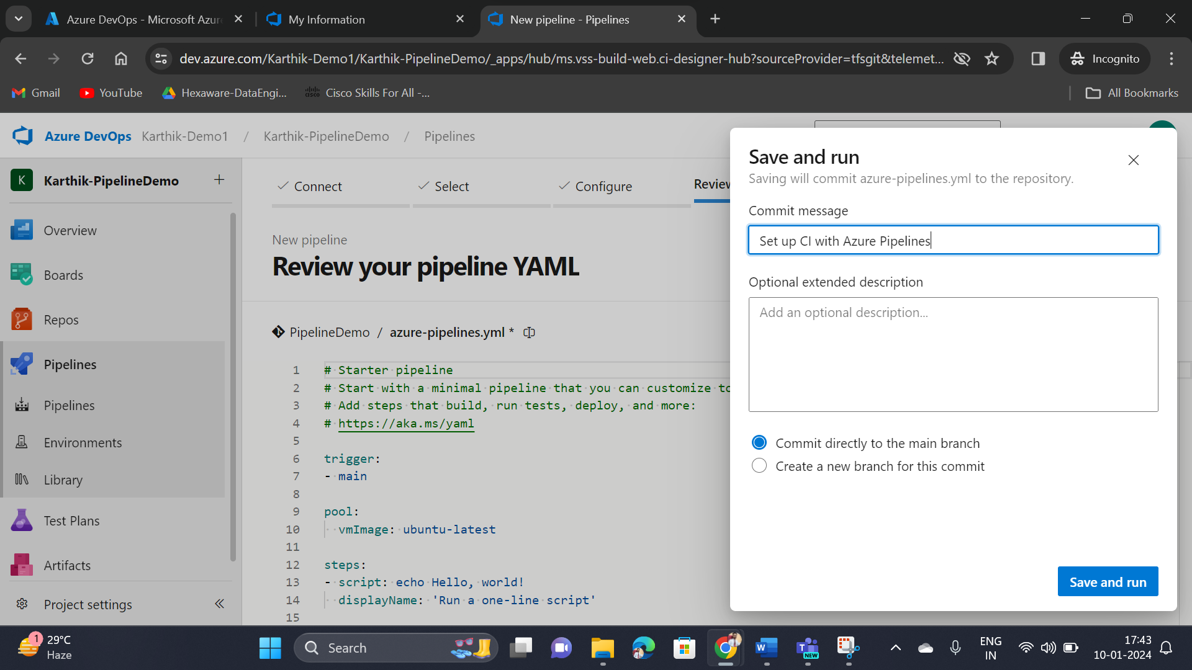

**Step-9**: Now the pipeline has been created successfully

